Nikit Gokhe

Class – Comp D1

Roll No. 224024

GR No. 21810522

**ASSIGNMENT NO.02**

**AIM:-**

Design at least 10 SQL queries for suitable database application using SQL DML statements: Insert, Select, Update, Delete with operators, functions, Set operators, Clauses.

**THEORY:-**

**Data Manipulation Language (DML) Statements :**

Data manipulation language (DML) statements access and manipulate data in existing schema objects.

The data manipulation language statements are: INSERT, UPDATE, DELETE, SELECT

**INSERT:-**

There are two basic syntax of INSERT INTO statement as follows:

INSERT INTO TABLE_NAME (column1, column2, column3,…columnN)] VALUES (value1, value2, value3,…valueN);

Here, column1, column2,…columnN are the names of the columns in the table into which want to insert data. It‟s not required to specify the column(s) name in the SQL query if values for all the columns of the table are provided. But make sure the order of the values is in the same order as the columns in the table. The SQL INSERT INTO syntax would be as follows:

INSERT INTO TABLE_NAME VALUES (value1,value2,value3,…valueN);

**SELECT:-**

Syntax: The basic syntax of SELECT statement is as follows:

SELECT column1, column2, columnN FROM table_name;

Here, column1, column2…are the fields of a table whose values you want to fetch. If you want to fetch all the fields available in the field, then you can use the following syntax:

SELECT * FROM table_name;

**AND operator:-**

The SQL AND and OR operators are used to combine multiple conditions to narrow data in an SQL statement. These two operators are called conjunctive operators. These operators provide a means to make multiple comparisons with different operators in the same SQL statement.

The AND Operator: The AND operator allows the existence of multiple conditions in an SQL statement‟s WHERE clause.

Syntax: The basic syntax of AND operator with WHERE clause is as follows:

SELECT column1, column2, columnN FROM table_name WHERE [condition1] AND [condition2]…AND [conditionN];

You can combine N number of conditions using AND operator. For an action to be taken by the SQL statement, whether it be a transaction or query, all conditions separated by the AND must be TRUE.

**OR operator:-**

The OR operator is used to combine multiple conditions in an SQL statement‟s WHERE clause. Syntax: The basic syntax of OR operator with WHERE clause is as follows:

SELECT column1, column2, columnN FROM table_name WHERE [condition1] OR [condition2]…OR [conditionN]

You can combine N number of conditions using OR operator. For an action to be taken by the SQL statement, whether it be a transaction or query, only any ONE of the conditions separated by the OR must be TRUE.

**GROUP BY clause:-**

The SQL GROUP BY clause is used in collaboration with the SELECT statement to arrange identical data into groups. The GROUP BY clause follows the WHERE clause in a SELECT statement and precedes the ORDER BY clause.

Syntax: The basic syntax of GROUP BY clause is given below. The GROUP BY clause must follow the conditions in the WHERE clause and must precede the ORDER BY clause if one is used.

SELECT column1, column2 FROM table_name WHERE [ conditions ] GROUP BY column1, column2

**UPDATE:-**

The SQL UPDATE Query is used to modify the existing records in a table. You can use WHERE clause with UPDATE query to update selected rows otherwise all the rows would be affected.

Syntax: The basic syntax of UPDATE query with WHERE clause is as follows:

UPDATE table_name SET column1 = value1, column2 = value2…., columnN = valueN WHERE [condition]; You can combine N number of conditions using AND or OR operators.

**DELETE:-**

The SQL DELETE Query is used to delete the existing records from a table. You can use WHERE clause with DELETE query to delete selected rows, otherwise all the records would be deleted.

Syntax: The basic syntax of DELETE query with WHERE clause is as follows:

DELETE FROM table_name WHERE [condition]; You can combine N number of conditions using AND or OR operators.

**SET OPERATOR:-**

Set Operations The SQL operations union, intersect, and except operate on relations and correspond to the mathematical set-theory operations ∪, ∩, and −.

**Queries:**

1. Create table info(sr_no int(20), NAME VARCHAR(256),GR_NO INT(20), HOBBY VARCHAR(256), AGE INT(20));
2. INSERT INTO INFO * VALUES(5,”VIDHI”,21810481,”BOXING”,20);
3. INSERT INTO INFO * VALUES(6,”AYUSHI”,21810681,”BADMINTON”,20)
4. Select * from info
5. Select * from info

Update into set sr_no=2

Where NAME = “Abhinav”;

1. Select* from info union select * from info 2;
2. Select * from info union all select*from info2;
3. SELECT * FROM INFO WHERE NAME =”RAUNAK” AND NAME=”VIDHI” AND NAME=”OMKAR”;
4. SELECT SR_NO FROM INFO WHERE (NAME=”RAUNAK” AND SR_NO =3);
5. SELECT SR_NO , GR_NO , HOBBY FROM INFO WHERE(NAME =”RAUNAK” OR SR_NO =4);

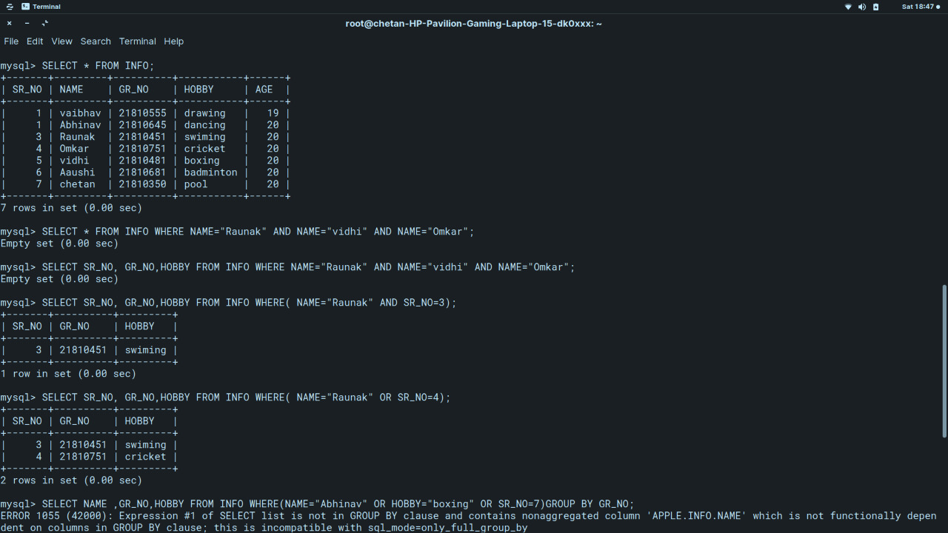

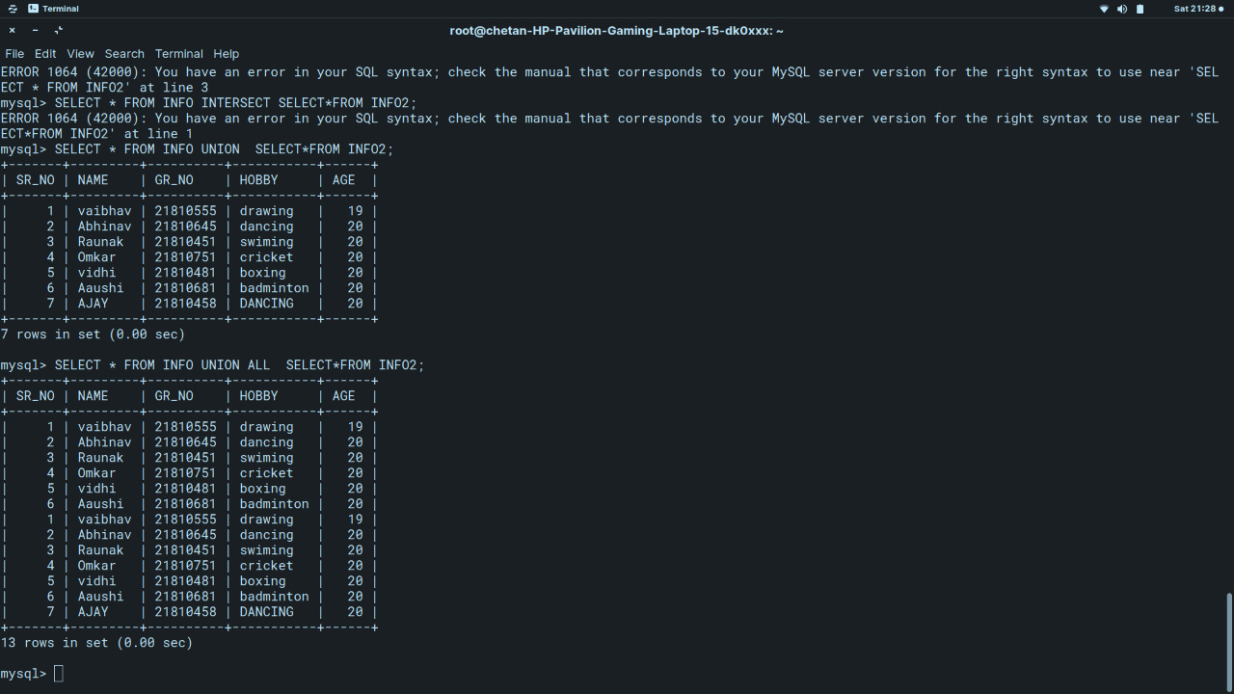

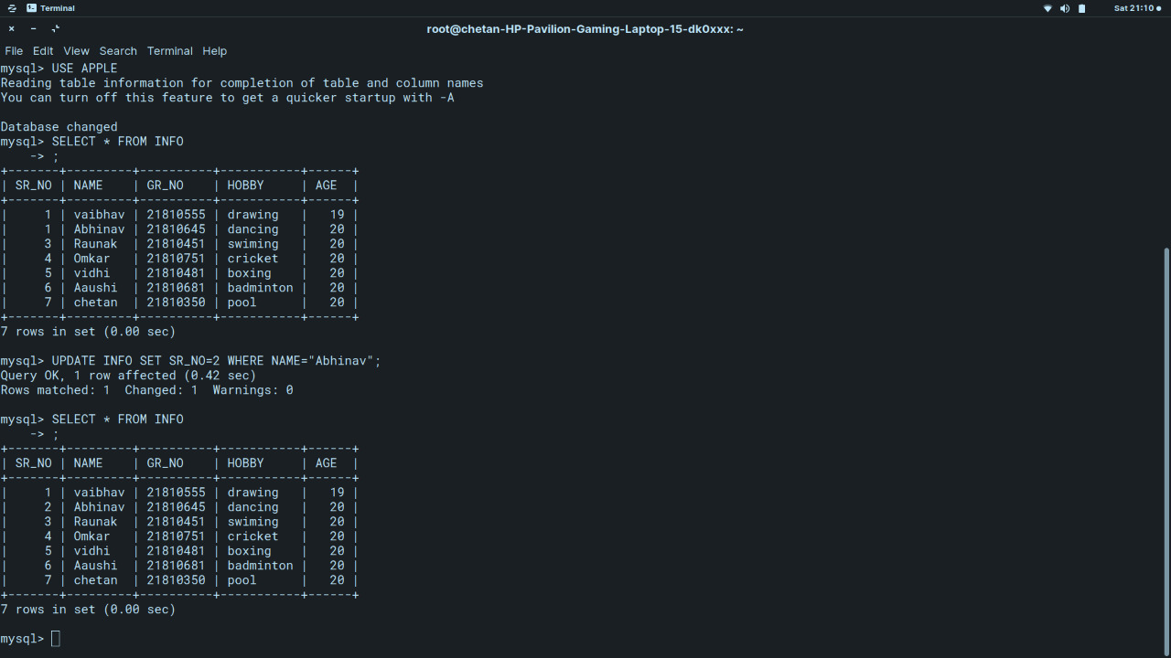

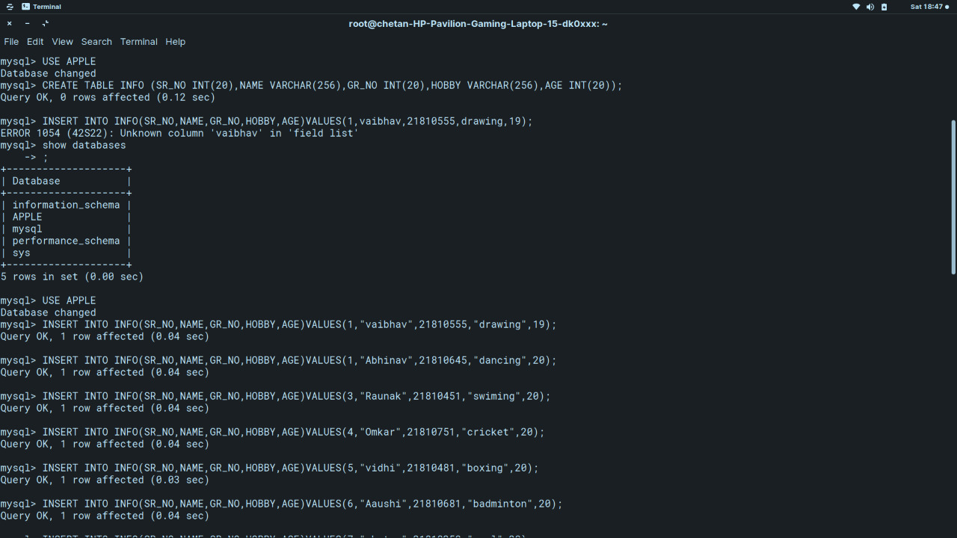

**CONCLUSION:-**

**Hence details about various DML commands and aggregate functions with GROUP BY clause are provided.**